Project Report

ZHU DONGYU

Boston University

Author Note

### This paper was prepared for Database Design and Implementation for Business, taught by Professor Edward Matthews.

# Part1

* structural business rules

Business rule:

1. A seller must provide his phone and his address.

2. A customer must provide his phone, address and e-mail.

3. When a product is added, the info of the product such as the name and the description is needed.

4. After sending to the Amazon warehouse, the inventory could be shown.

5. When a customer makes an order, the delivery address is associate to the address provided when registering.

6. There are four kinds of speed on shipping: super saver shipping, standard shipping, two‐day, one‐day.

7. Each product must have its category.

8. Each order has only one package.

9. When making an order, you can only buy one product with different counts.

# Part2

* ERD and EERD graph

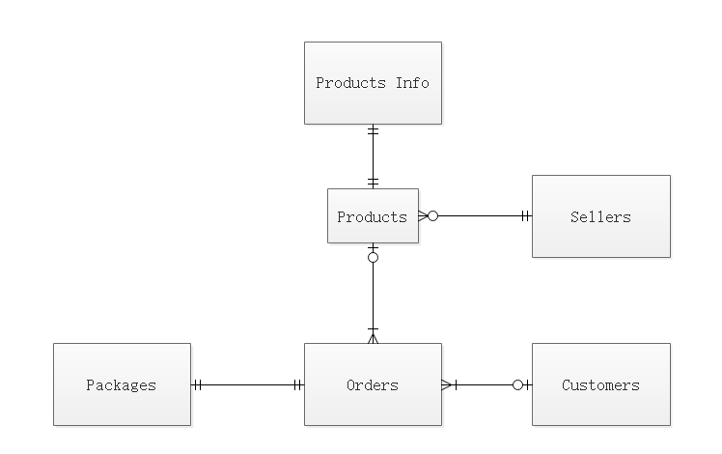

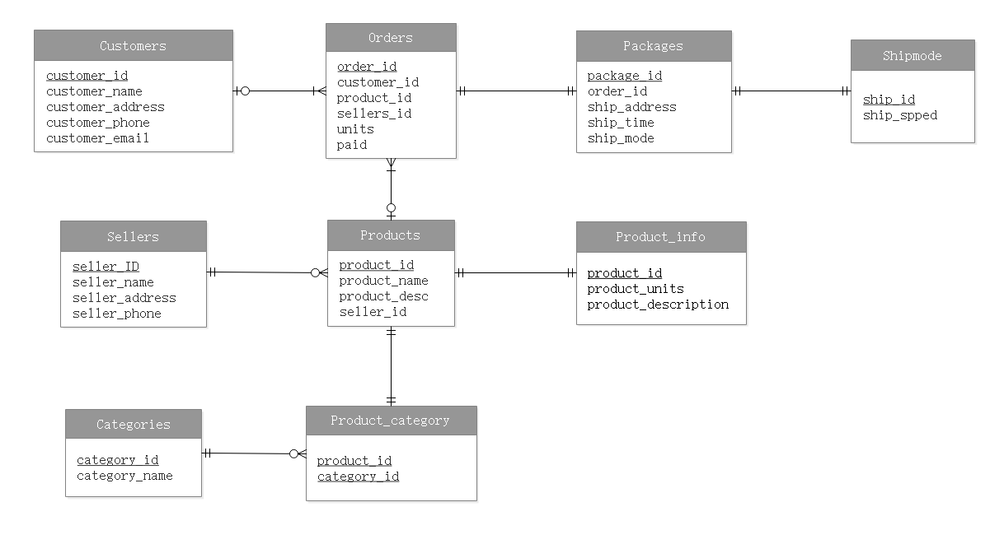

# Part3

Screen shot for five aspects

* Aspect 1

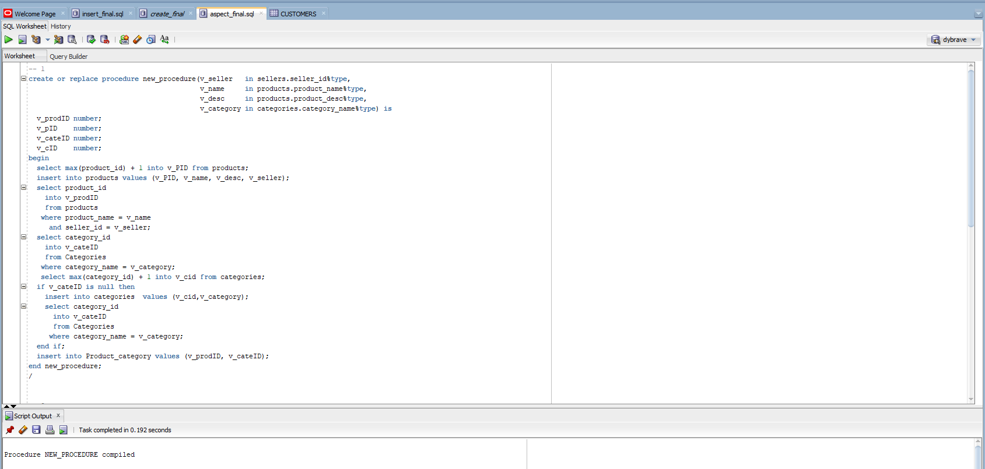

* Aspect 2

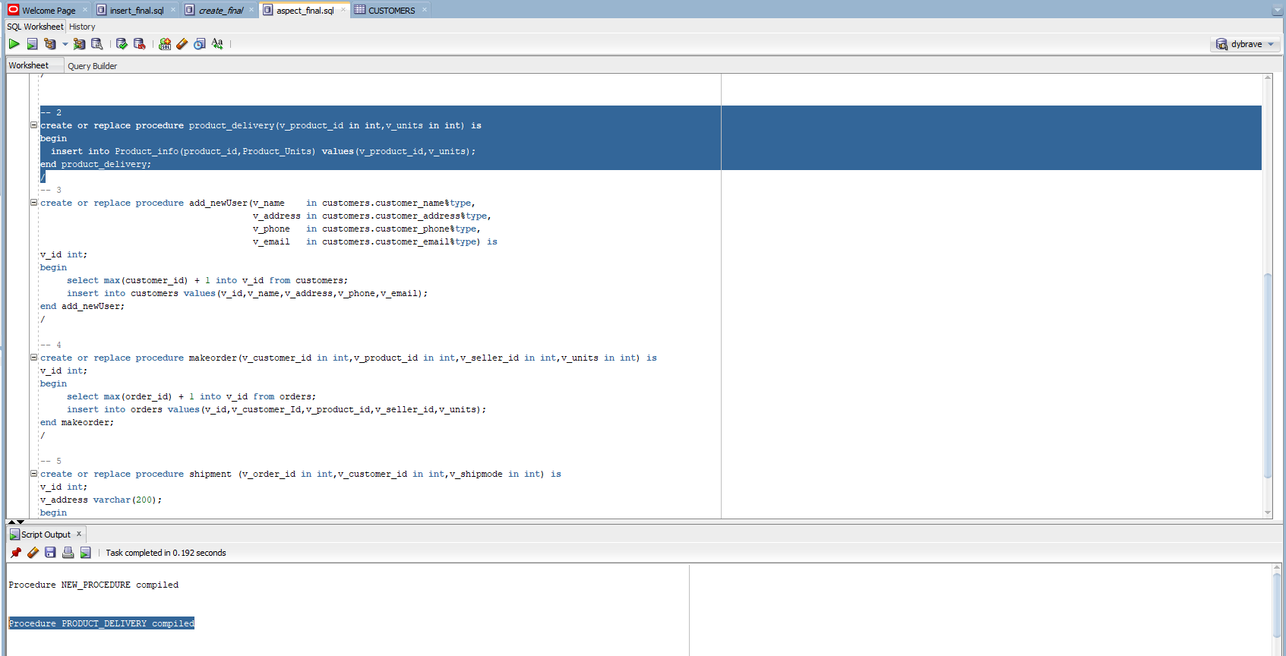

* Aspect 3

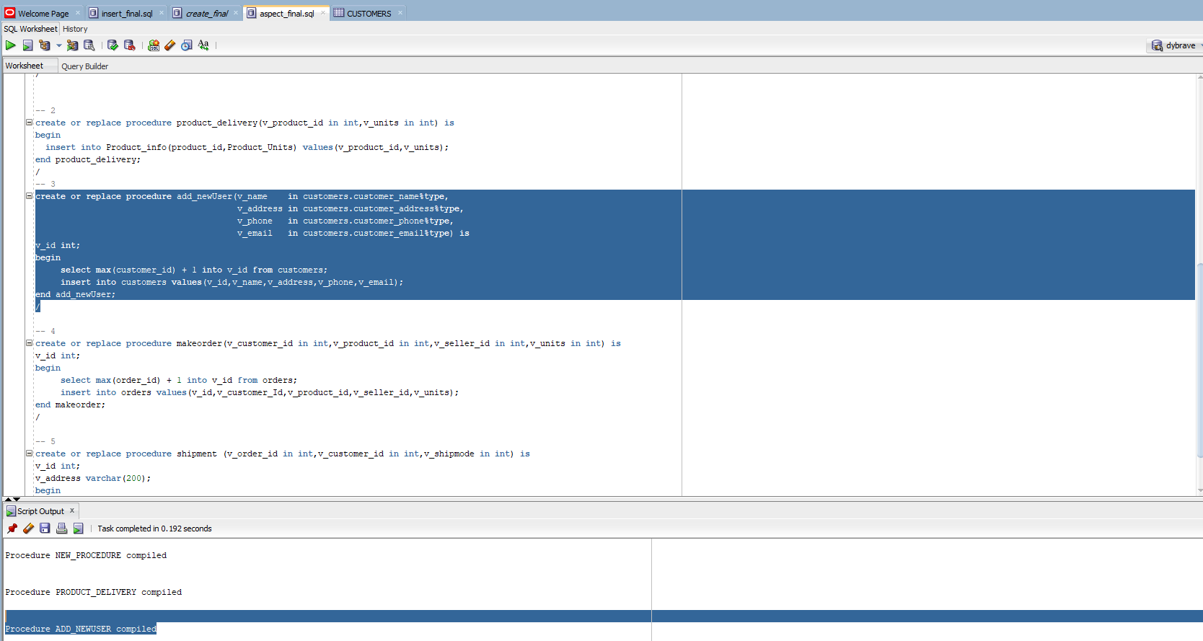

* Aspect 4

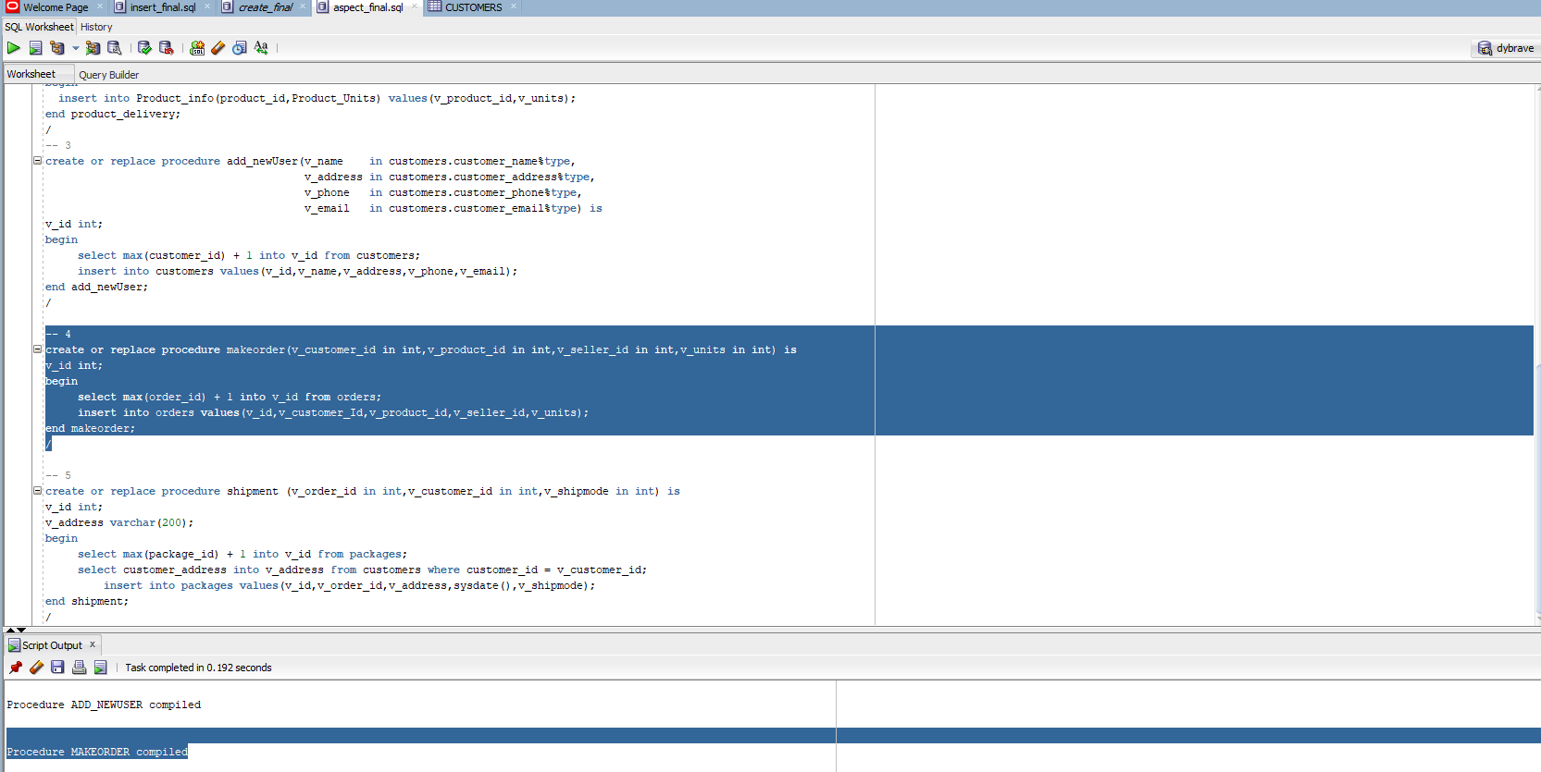

* Aspect 5

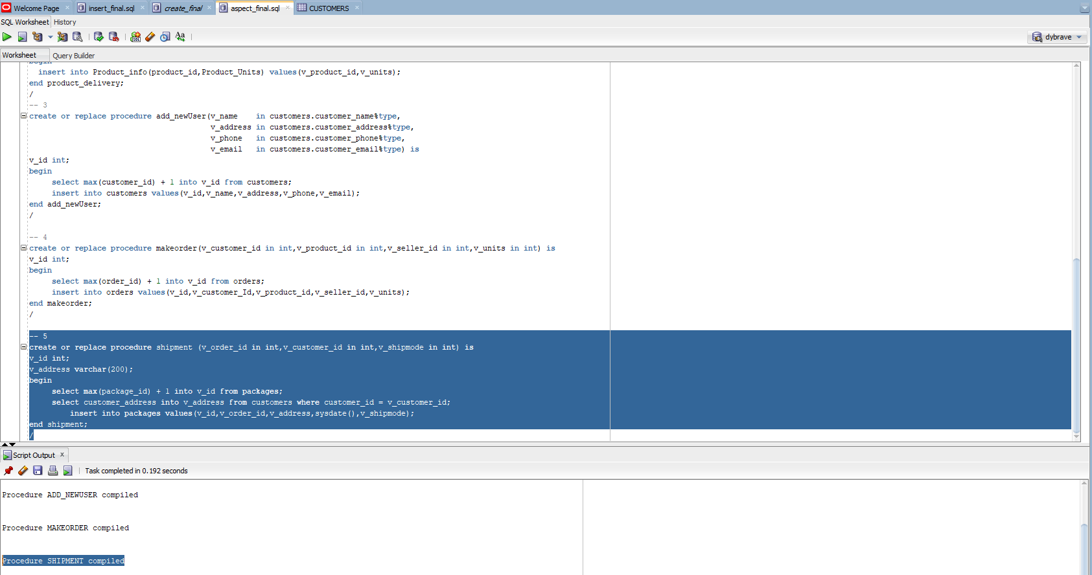

# Index

* Screenshot

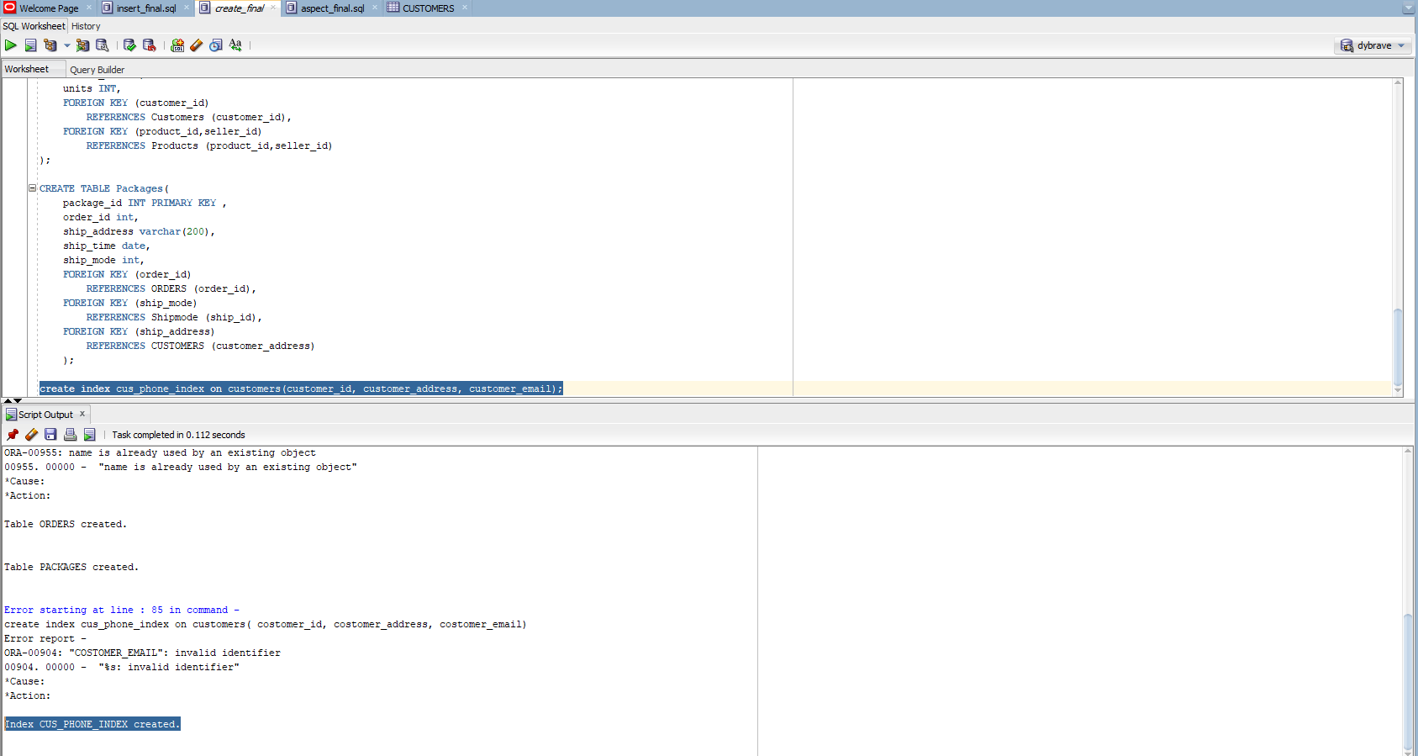

* Answer
* I think when I try to build an index for a database, we have to take into account that this Index should be commonly used, and should not be very large, and easy to enter the search. So this reminds me of it. When I was having problems of buying Amazon products. I would call customer service to help me. The services usually ask me to provide my phone number for them to authenticate, no matter what service I need, such as query Order, change the password, or forget the email address. So I chose to create an Index for the customer phone number. I think this is necessary because the phone number is made up of numbers, easy to repeat, the query is fast and usually unique.